Google Cloud

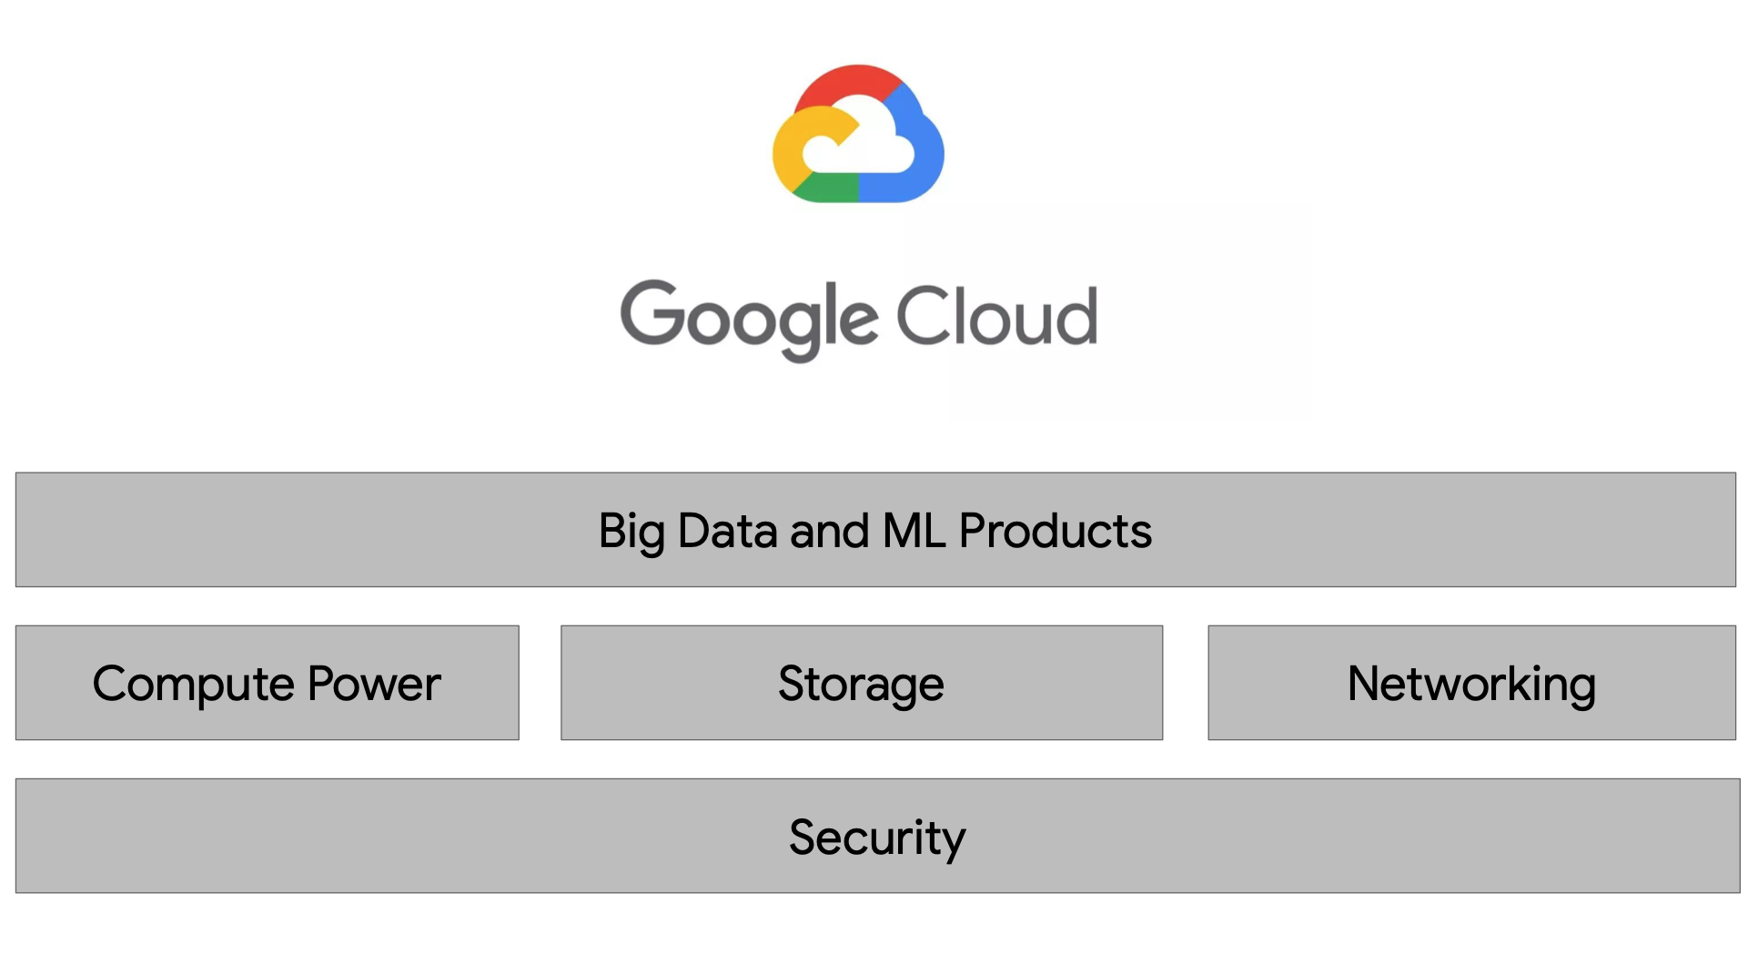

There are four fundamental aspects of Google’s core infrastructure and a top layer of products and services that you’ll interact with most often.

1. **Security (Base Layer)**  
   The base layer that covers all of Google’s application is security.
2. **Compute, Storage and Networking**  
   On top of that are compute, storage, and networking. These allow you to process, store, and deliver those business-changing insights, data pipelines, and ML models.
3. **Big Data and ML Products**  
   Finally running your Big Data applications on bare metal virtual machines is possible, Google has developed the top layer of big data and ML products to abstract away a lot of the hard work and managing and scaling the infrastructure for you.

A growing data organization like yours will need lots of compute power to run big data jobs -- especially as you design for the future to outpace your growth in new users and data for the next decade.

# Google Storage

There are four storage classes for you to choose from based on your data needs.

* Standard Storage
* Nearline Storage
* Coldline Storage, and
* Archive Storage
* Regardless of which one you choose, all classes have multi-region, dual-region, and region location options.
* Bucket names have to be globally unique and GCP assigns a project id that is globally unique too.

# GCP Resource Hierarchy

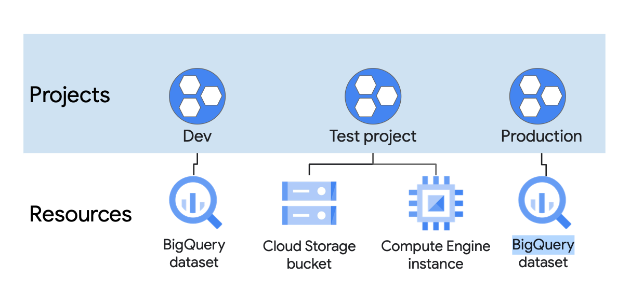

## **Project**

A project is the base level organising entity for creating and using resources and services and managing billing, API’s and permissions.

Zones and regions physically organise the GCP resources you use, projects and logically organise them. Projects can be easily created, managed, deleted or even recovered from accidental deletion.

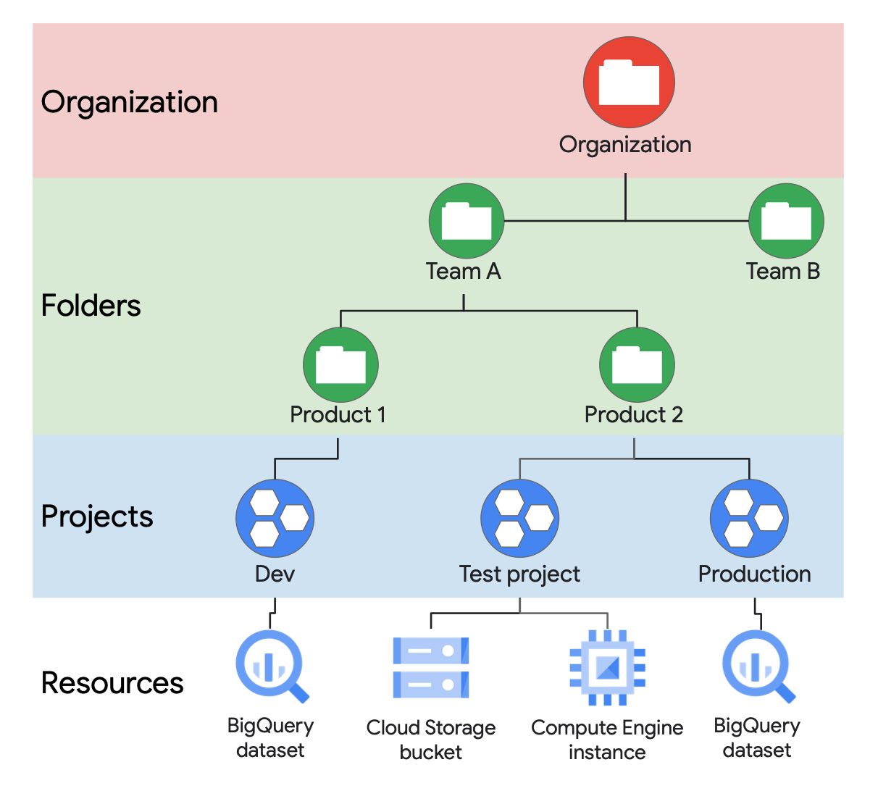

**Folders** are another logical grouping you can have for collections of projects. Having an organisation is required to use folders, and the organisation is the root node of the entire GCP hierarchy.

Lastly, while not required, an organisation is quite useful because it will allow you set policies that apply throughout the enterprise.